Marc, Franz (1880-1916)
Dagmar Grimm
Franz Marc was born in Munich, Germany in 1880 and died in the battle of Verdun in 1916, one of many of the Great War’s tragic losses.
Formerly a student of theology and philosophy, Marc studied at the Art Academy in Munich and first exhibited there at the Galerie Brakl in February 1910. As a proponent of the new direction in art, he emphasized its spiritual essence as opposed to the materialism inherent in the work of the past. He was interested in aesthetic theory – to deconstruct and find a parallel way to that of science to arrive at what lies concealed under the cover of outward appearance.

Marc believed that ideas could be more important than paintings. With Wassily Kandinsky, he became the co-founder of Der Blaue Reiter (The Blue Rider), a loosely affiliated group of avant-garde artists who worked together to effect a reformation of all of the arts, emphasizing their spirituality. Marc and Kandinsky served as the editors of Der Blaue Reiter Almanach, published in 1912, which addressed the programmatic issues of the progressive group. Influenced by Cubism and Futurism, Marc created works in which transparent planes of color interpenetrate: forms and colors pervading each other, splintering trees, plants, and cattle aglow with the sun’s rays on a dynamic, variegated, yet unified surface. This prefigures his more mannered, tight, and definite later style, a transition demonstrated in a comparison of the free-flowing, organic rhythm of Red Horses (1911) to the tight crystalline structure of Tower of Blue Horses (1913), both exhibited at the First German Autumn Salon, 1913.

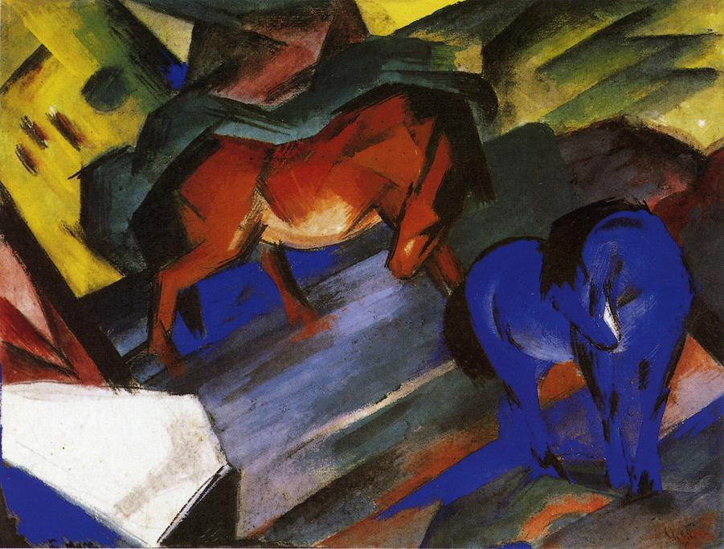
Red and Blue Horse 1912
ww.wikipaintings.org/en/franz-marc/red-and-blue-horse-1912

Marc was indebted to Kandinsky for his free use of color. He was interested in color for its emotional effect and later in its symbolism, with which he used to explore plant and animal life. He also studied the anatomy of animals, sketching from nature and at the zoological gardens, and studied bone structure at natural history museums in order to achieve ‘pantheistic empathy’ in his work.
Marc’s aim was to allow the object to express its spirit. Along with Kandinsky, Marc believed that in order to express the spirit, art must be dematerialized. A scientific parallel is the transmutation of matter into energy—an example of ‘liberation’ from the material. This belief led to a different set of pictorial aims and a new art form—non-objective painting.
In 1914, Marc painted a series of abstract paintings in which his style changed from the angularity of sharp, splintered forms to curvilinear shapes and circular movement. He tried to create an organic, dynamic reality that recognized spirit, vitality, and change. In his last paintings, he had almost completely departed from the object as subject.
A casualty of World War I, Marc died near Verdun on March 4, 1916 at age thirty-six. Despite his war hero status, and a brief adulatory period in which the National Socialists identified him as a great German painter, 130 of his works were confiscated from German public collections under the National Socialists. Five of his paintings were included in The Degenerate Art Exhibition of 1937, but upon the protests of the German Officers Federation, the great Tower of Blue Horses (1913) was finally exempted and subsequently seized by Hermann Göring, remaining in the hands of the Nazis until 1945. Its current whereabouts are unknown.

Further Reading:
Barron, Stephanie (ed.), Degenerate Art: The Fate of the Avant-Garde in Nazi Germany (exh. cat.) Los Angeles: Los Angeles County Museum of Art, 1991.
Selz, Peter, German Expressionist Painting. Berkeley, Los Angeles: University of California Press, 1974.

